External Library / SDK Resource

📝Definition
# Source: AI Source: Provided by: [Data Path: Persons Table -> ID Column: 1, Name_En Column: Motasem Essam] -> From: [ChatGPT] on [1/23/2026]
An External Library / SDK Resource is a third-party package, tool, or framework that your application uses to add functionality without building it from scratch.
👉 Think of it as a pre-built solution you plug into your app to save time and effort.

🔑 Key Points
# Source: AI Source: Provided by: [Data Path: Persons Table -> ID Column: 1, Name_En Column: Motasem Essam] -> From: [ChatGPT] on [1/23/2026]
- Provides ready-made functionality (HTTP calls, UI components, authentication, etc.)
- Reduces development time and complexity
- Maintained by external developers or organizations
- Must be used carefully to avoid tight coupling or over-dependence

🧱 Examples

1️⃣ JavaScript Libraries
# Source: AI Source: Provided by: [Data Path: Persons Table -> ID Column: 1, Name_En Column: Motasem Essam] -> From: [ChatGPT] on [1/23/2026]
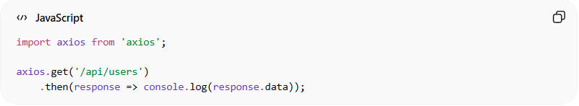
import axios from 'axios';

axios.get('/api/users')
.then(response => console.log(response.data));
👉 Here:
- axios is an external library resource
- Handles HTTP requests instead of writing low-level code

2️⃣ Laravel / PHP Packages
# Source: AI Source: Provided by: [Data Path: Persons Table -> ID Column: 1, Name_En Column: Motasem Essam] -> From: [ChatGPT] on [1/23/2026]
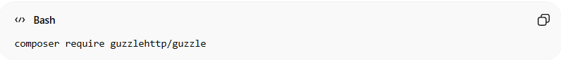
composer require guzzlehttp/guzzle
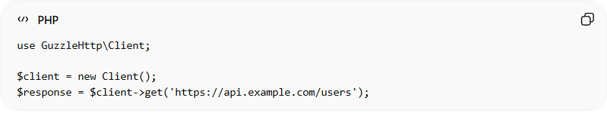
use GuzzleHttp\Client;

$client = new Client();
$response = $client->get('https://api.example.com/users');
👉 Here:
- guzzlehttp/guzzle is an external SDK/library
- Used for making HTTP requests

3️⃣ UI Libraries
# Source: AI Source: Provided by: [Data Path: Persons Table -> ID Column: 1, Name_En Column: Motasem Essam] -> From: [ChatGPT] on [1/23/2026]
- React, Vue, Angular → UI frameworks
- Bootstrap, Tailwind → styling libraries
👉 These are external resources for UI development

❌ Bad Example
# Source: AI Source: Provided by: [Data Path: Persons Table -> ID Column: 1, Name_En Column: Motasem Essam] -> From: [ChatGPT] on [1/23/2026]
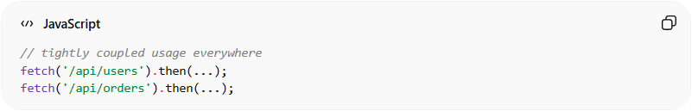
// tightly coupled usage everywhere
fetch('/api/users').then(...);
fetch('/api/orders').then(...);
Problems:
- No abstraction
- Hard to replace or change library
- Repeated logic everywhere

✅ Good Example
# Source: AI Source: Provided by: [Data Path: Persons Table -> ID Column: 1, Name_En Column: Motasem Essam] -> From: [ChatGPT] on [1/23/2026]
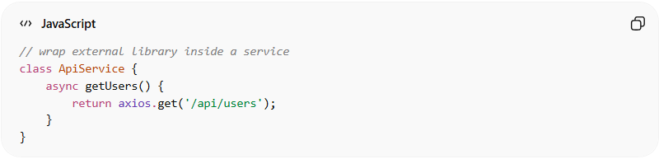
// wrap external library inside a service
class ApiService {
async getUsers() {
return axios.get('/api/users');
}
}
- External library is abstracted inside service ✅
- Easy to replace later ✅
- Cleaner and reusable ✅

⚠️ Common Mistakes
# Source: AI Source: Provided by: [Data Path: Persons Table -> ID Column: 1, Name_En Column: Motasem Essam] -> From: [ChatGPT] on [1/23/2026]
- Overusing too many libraries ❌
- Depending directly on libraries everywhere ❌
- Not isolating them behind services or adapters ❌

🔄 Relation to Other Resources
# Source: AI Source: Provided by: [Data Path: Persons Table -> ID Column: 1, Name_En Column: Motasem Essam] -> From: [ChatGPT] on [1/23/2026]
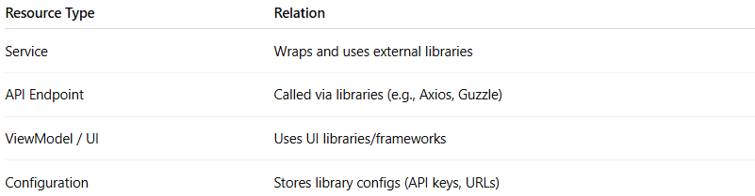
Resource Type | Relation
Service | Wraps and uses external libraries
API Endpoint | Called via libraries (e.g., Axios, Guzzle)
ViewModel / UI | Uses UI libraries/frameworks
Configuration | Stores library configs (API keys, URLs)

💡 Key Idea
# Source: AI Source: Provided by: [Data Path: Persons Table -> ID Column: 1, Name_En Column: Motasem Essam] -> From: [ChatGPT] on [1/23/2026]
External Libraries/SDKs are powerful reusable resources, but should be abstracted and controlled to keep your system flexible and maintainable.

🧾 Summary
# Source: AI Source: Provided by: [Data Path: Persons Table -> ID Column: 1, Name_En Column: Motasem Essam] -> From: [ChatGPT] on [1/23/2026]
- Provide pre-built functionality
- Save time and effort
- Should be wrapped inside services
- Must be used carefully to avoid tight coupling

